Lua-GL tests

Objects
- Draw an object (e.g. rectangle) and
  - try moving it
  - try dragging it
- Draw an object and add a port to it
  - Check data structure to see port associated with object and the port visual object grouped with the object.
  - Move the object and see the port moves with it
  - Drag the object and see the port moves with it

Test Case 1 (Object Move and Drag)
- Load testcase1.lua (dofile("../test/testcase1.lua"))to draw the following diagram:
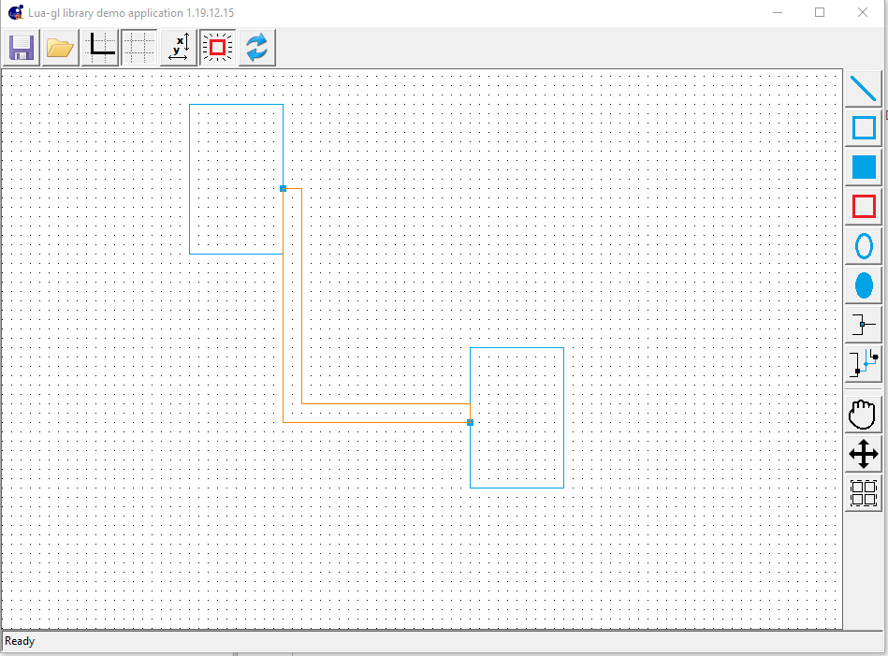
  - Check the order structure by doing
for i = 1,#cnvobj.drawn.order do print(cnvobj.drawn.order[i].type,cnvobj.drawn.order[i].item.id,cnvobj.drawn.order[i].item.order) end
    - Should see something like:
object O1
object O3
object O2
object O4
connector C2
connector C1
  - Drag one object to see connector redrawing
  - Move one object to disconnect it from the connectors. This will result in merging of the connectors to become 1 connector
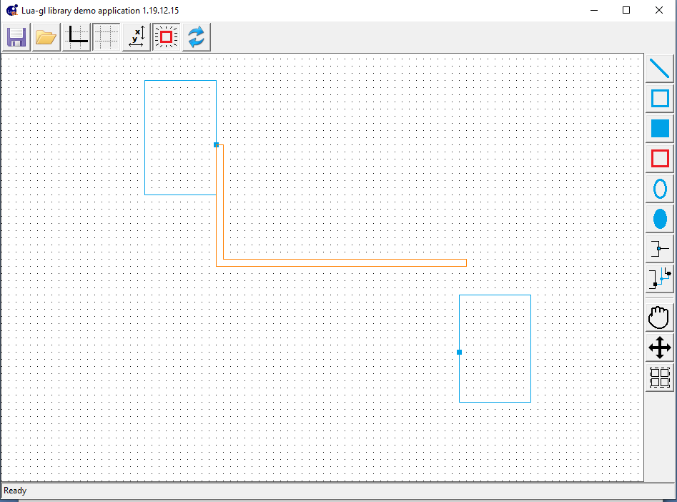
    - Check the connector data structure to see all segments in the single connector
    - Check the ports to see “P1” connecting to the single connector and “P2” connecting to no connectors.
    - Check the cnvobj.drawn.order structure to see 5 elements this time
  - Move the object back and connect it to the corner of the segment
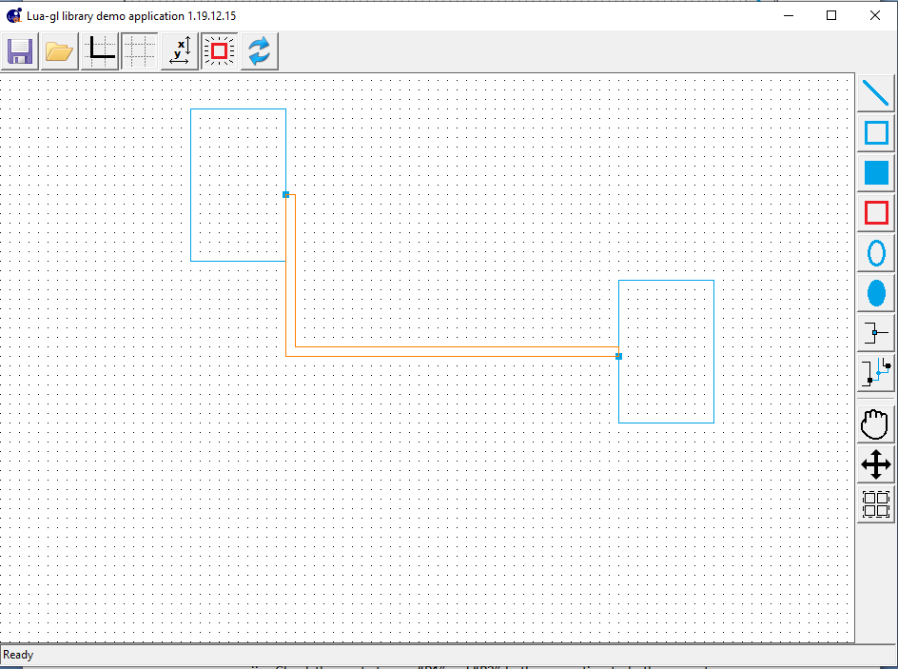
    - Check connector data structure to see 2 connectors again and segments distributed between them from 1 port to other port
    - Check the ports to see “P1”and “P2” both connecting to both connectors
    - Check the cnvobj.drawn.order structure to see 6 elements again
  - Move the object away from the connector, again merging the connector to 1. Then drag the object back again to the connect.
    - Check connector data structure to see 2 connectors again and segments distributed between them from 1 port to other port
    - Check the ports to see “P1”and “P2” both connecting to both connectors
    - Check the cnvobj.drawn.order structure to see 6 elements again
  - Move the object away from the connector, again merging the connector to 1. Then move the object back again this time placing the port somewhere midway in a segment.
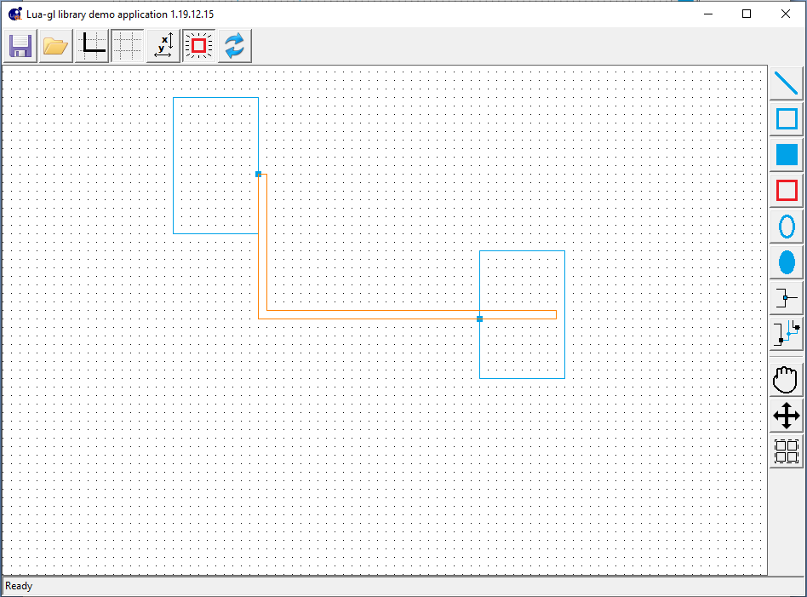
    - Check connector data structure to see 2 connectors again and segments distributed between them from 1 port to other port
    - Check the ports to see “P1”and “P2” both connecting to both connectors
    - Check the cnvobj.drawn.order structure to see 6 elements again and check the segments of the connectors to confirm the segment was split
  - Drag the object to see the connector redrawing again.
  - Select the drag function and select both the objects for drag. On doing the drag both connectors will be fully routed between the objects as shown:
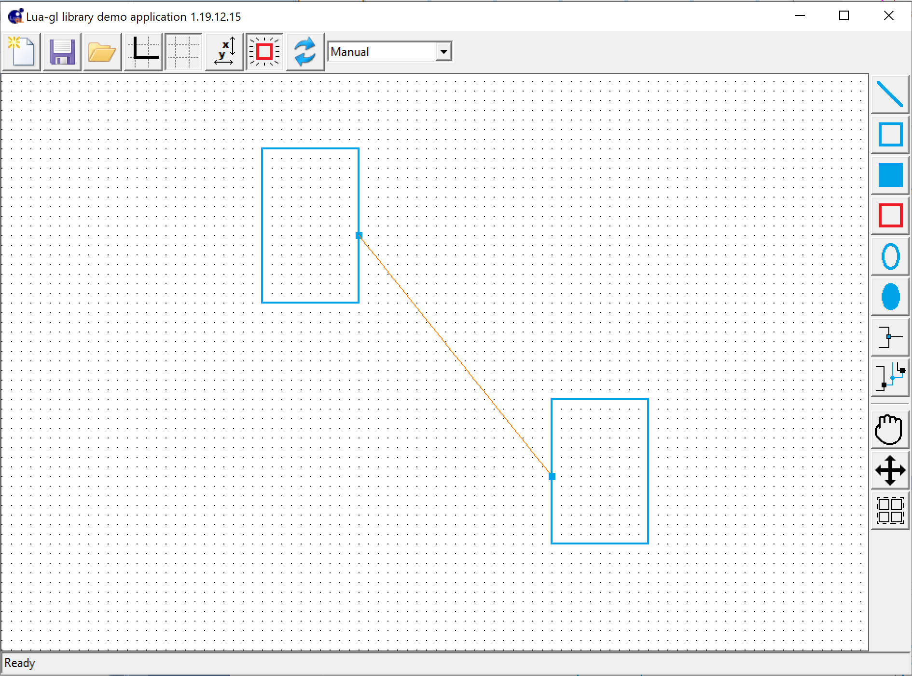
On ending the routing will be rerouted with BFS as:
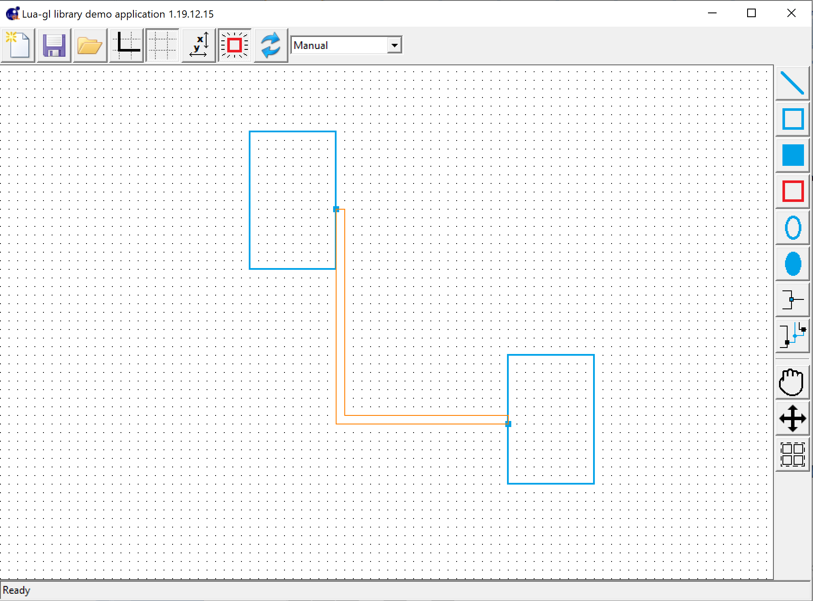
Make sure the routing matrix has right number of segments in hsegs and vsegs
- Load testcase1.lua (dofile("../test/testcase1.lua")) on a fresh run.
  - Drag one object so that one connector becomes straight i.e. it has only 1 segment then move the object away to disconnect. This should merge the 2 connectors
    - Check the order and other data structures

Test Case 2 (Connector Drawing)
- Load test case 2 in a fresh start by doing dofile("../test/testcase2.lua")
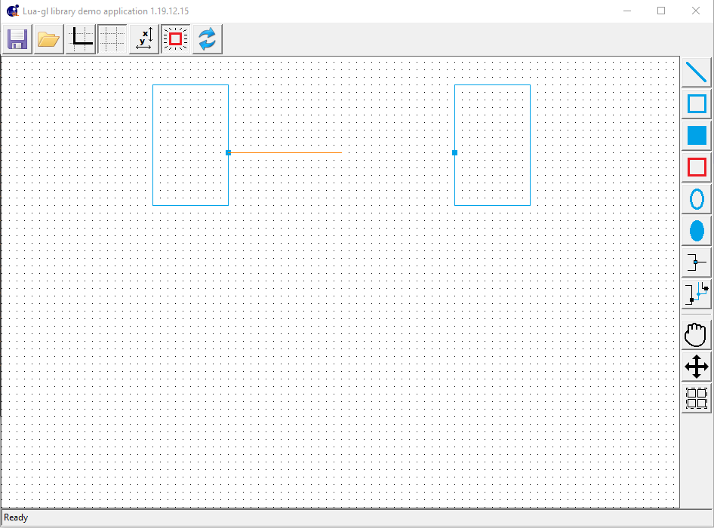
  - Now draw another connector from the object on the right to the end point of the connector already drawn and left click on it. This should end the connector and merge it with the already drawn connector. If there was no connector there left click would have created a way point there.

Test Case 3 (Connector Drawing – Junctions)
- Load test case 2 in a fresh start by doing dofile("../test/testcase3.lua")
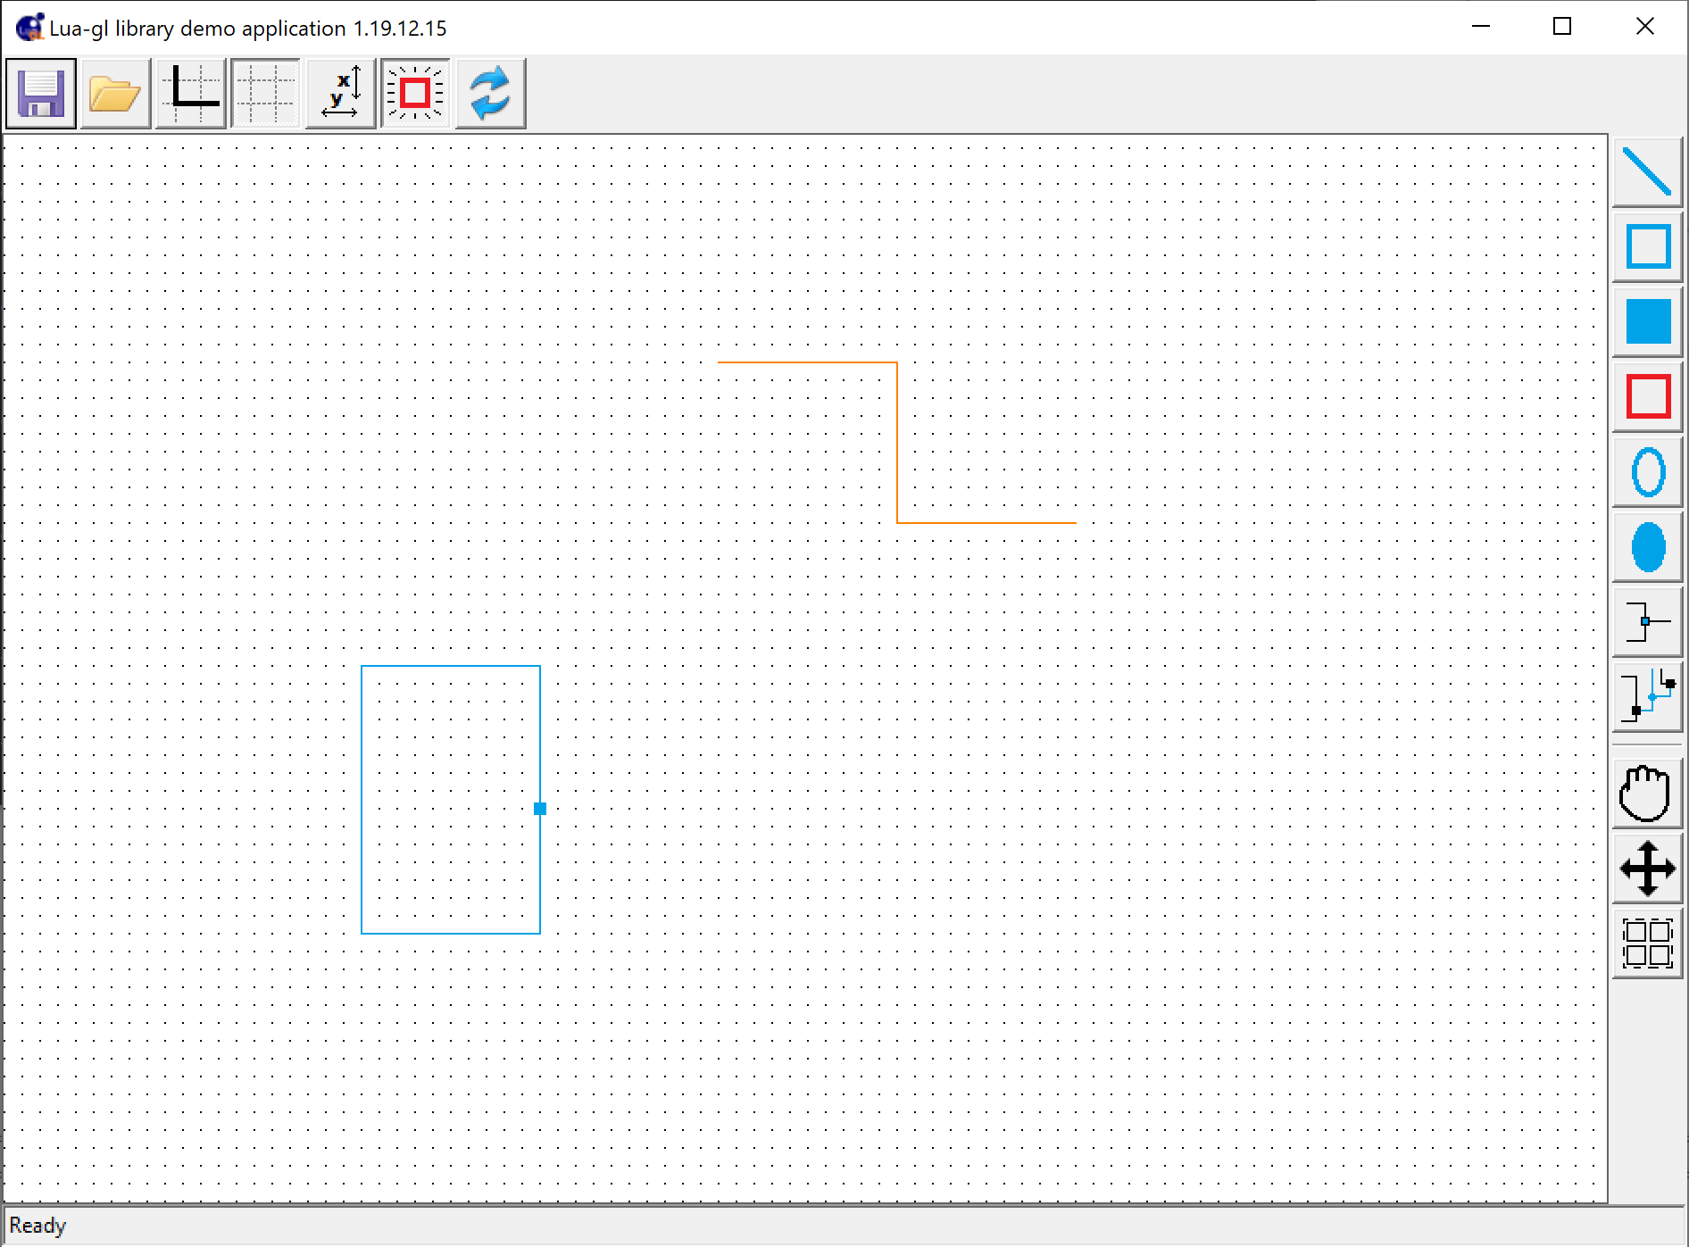
  - Now draw a connector from the port to corner shown above. Make sure the program does not hang. It should look like:
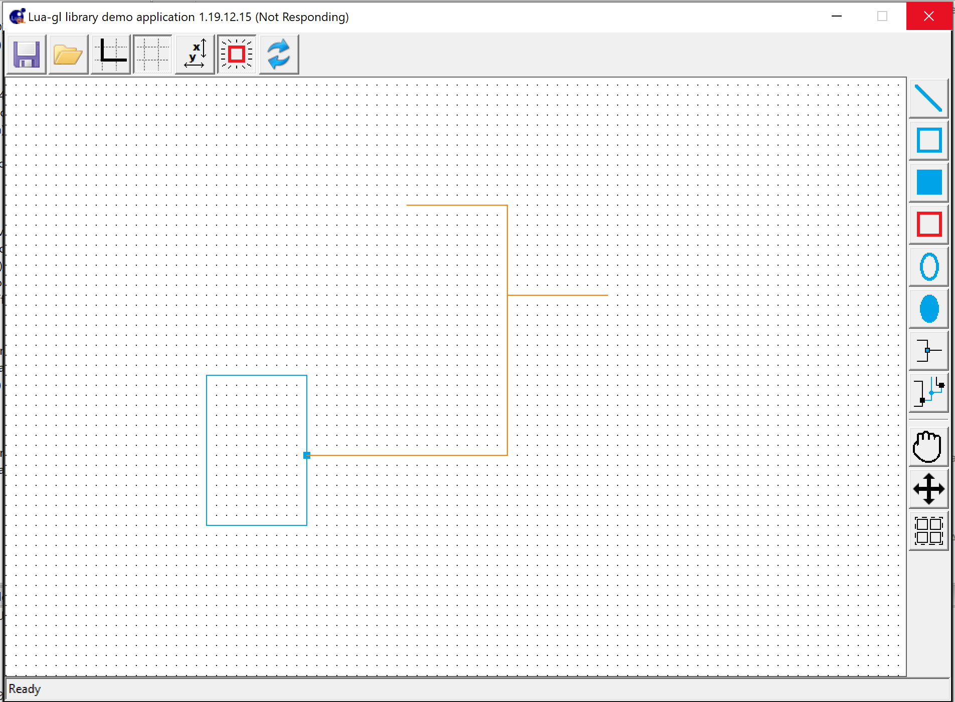

Test Case 4 (Connector Drawing)
- Load test case 2 in a fresh start by doing dofile("../test/testcase4.lua")
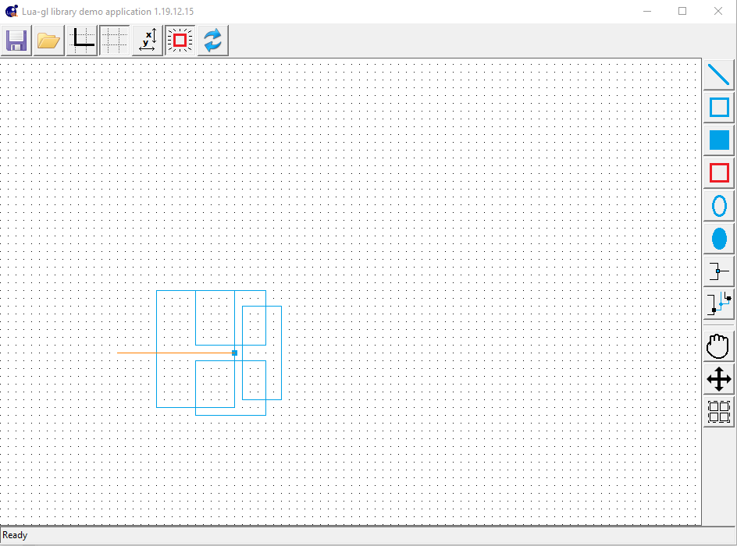
  - Now drawing a connector from the port cannot create any segment so generateSegments will just create a jumping connector and that can be in any direction. Something like this:
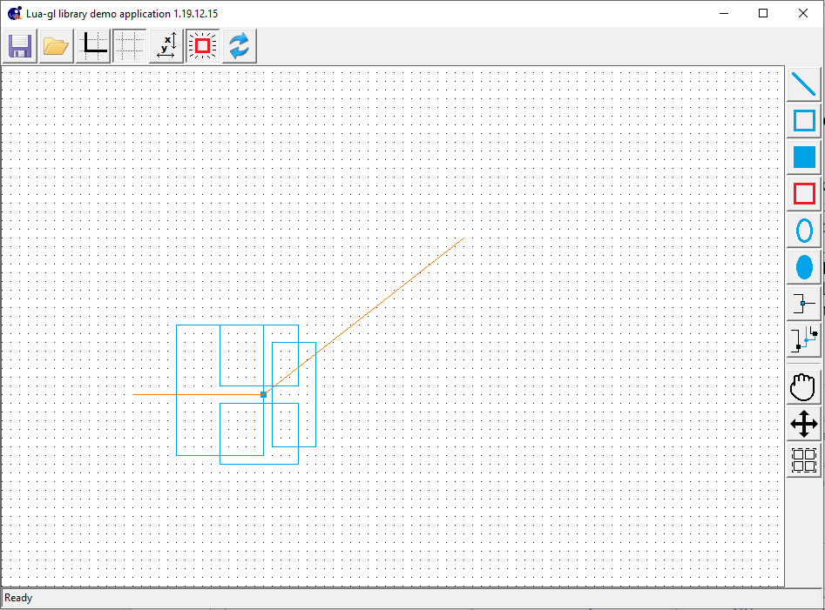

Test Case 5 (Connector Drawing)
- Load test case 2 in a fresh start by doing dofile("../test/testcase5.lua")
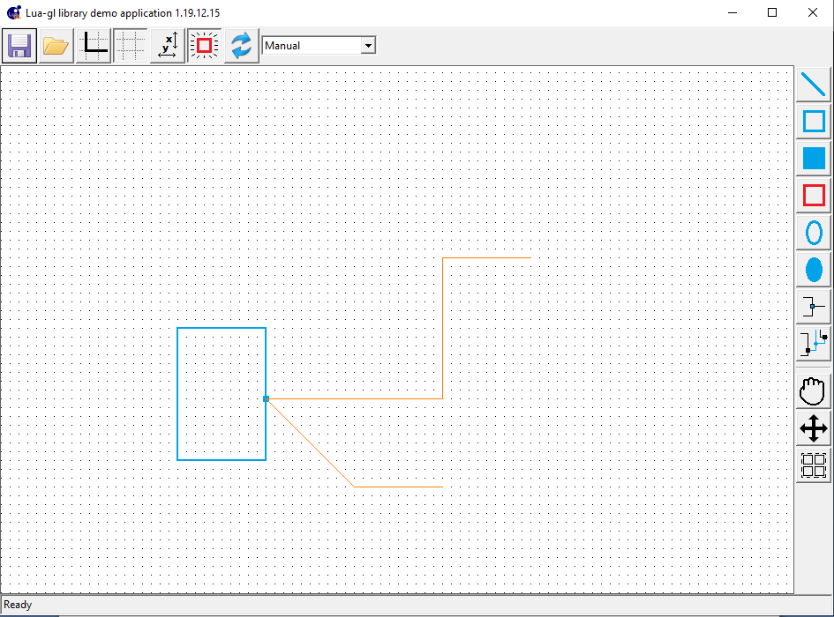
  - Draw a connector from the port to the right straight and put a way point (left click) at some point after the overlap with the standing connector ends as shown below:
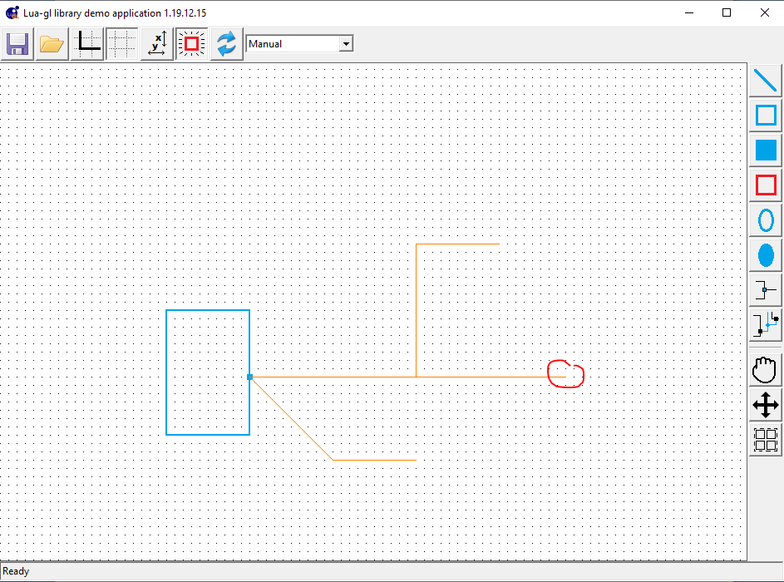
Take is further along the straight line and then end the connector (right click). This would create 2 segments of the connector along the same line and the 1st segment also overlaps with the standing connector. Look at the data structures. There should be 2 connectors, 1 with 2 segments (the slanting segment connector) and the other with 4 segments. Both should have the port. The connector with 4 segments should have a junction at 500,380

Test Case 6 (Object Drag)
- Load test case 2 in a fresh start by doing dofile("../test/testcase6.lua")
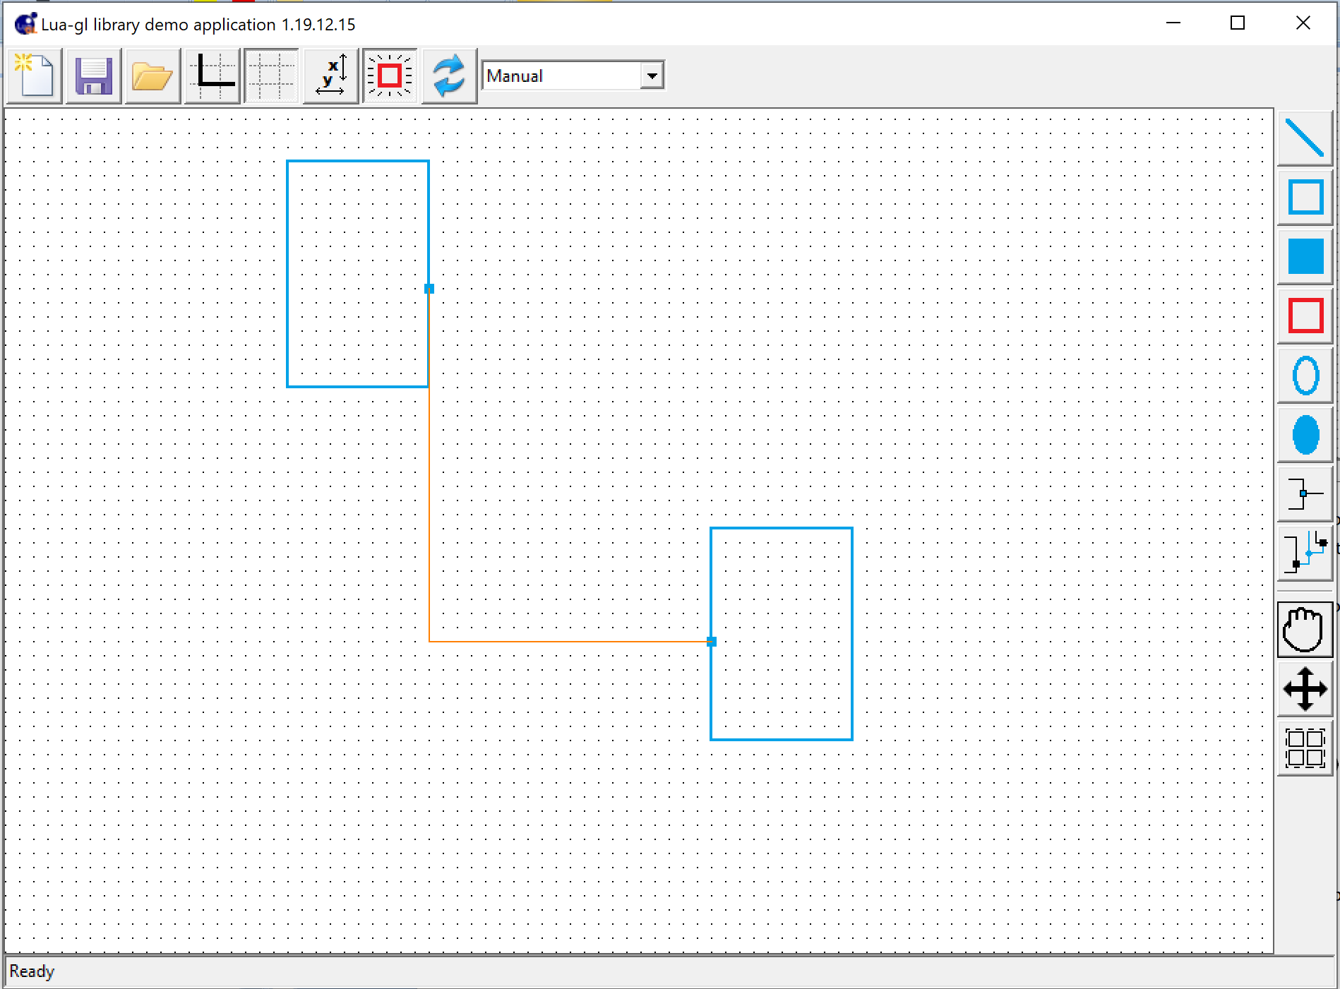
  - Select drag operation and select both objects for drag and then start the drag operation. It should pick the whole connector to be rerouted as shown below and when finished will reroute the whole connector using BFS:
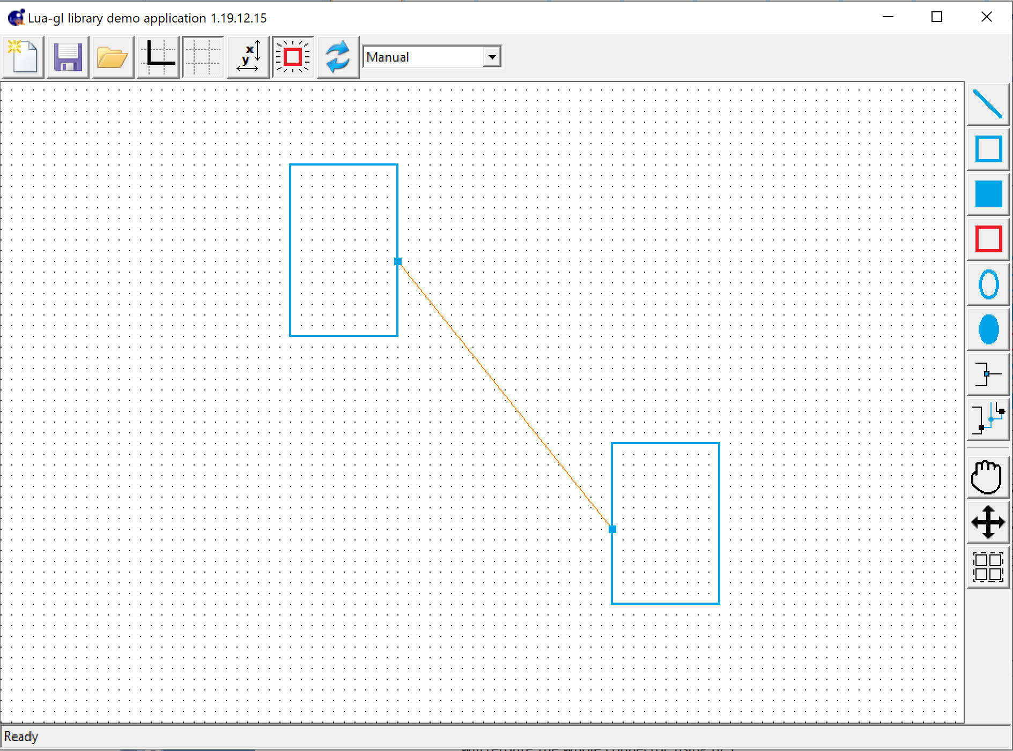
  - Now draw a connector from the middle of the connecting connector and end it somewhere as shown:
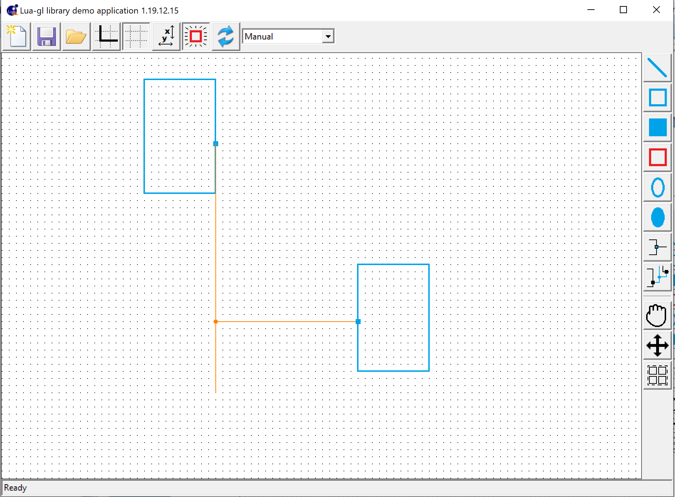
Now select both objects to drag and drag them. The connector will be routed to the junction as shown below:
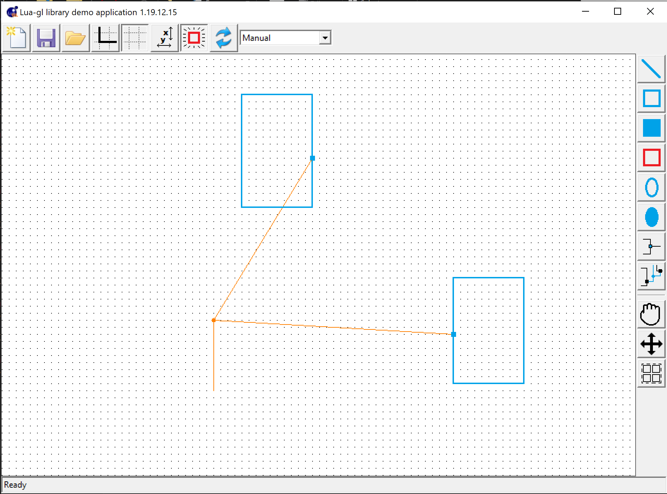
On ending the drag it will be something like:
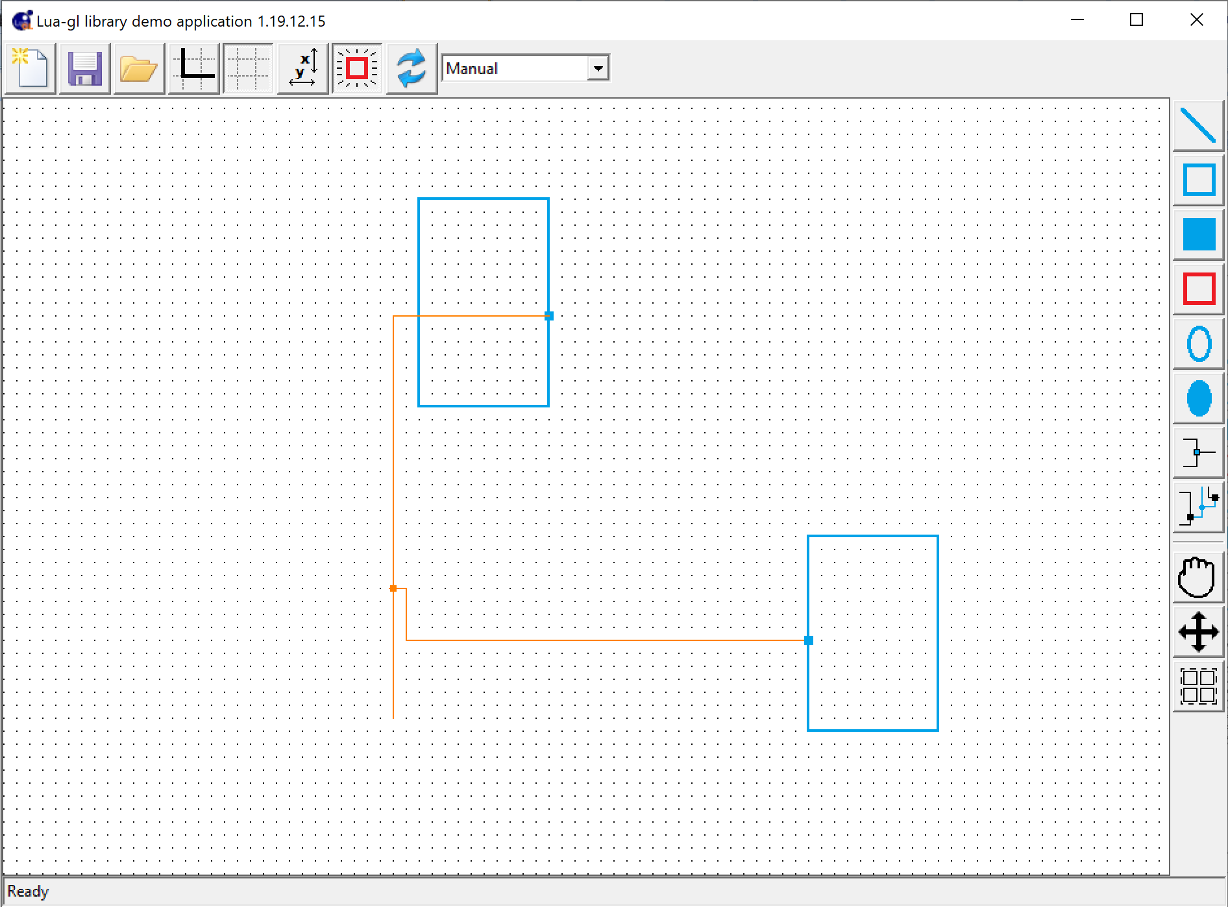

Test Case 7 (Segment Drag)
- Load test case 2 in a fresh start by doing dofile("../test/testcase7.lua")
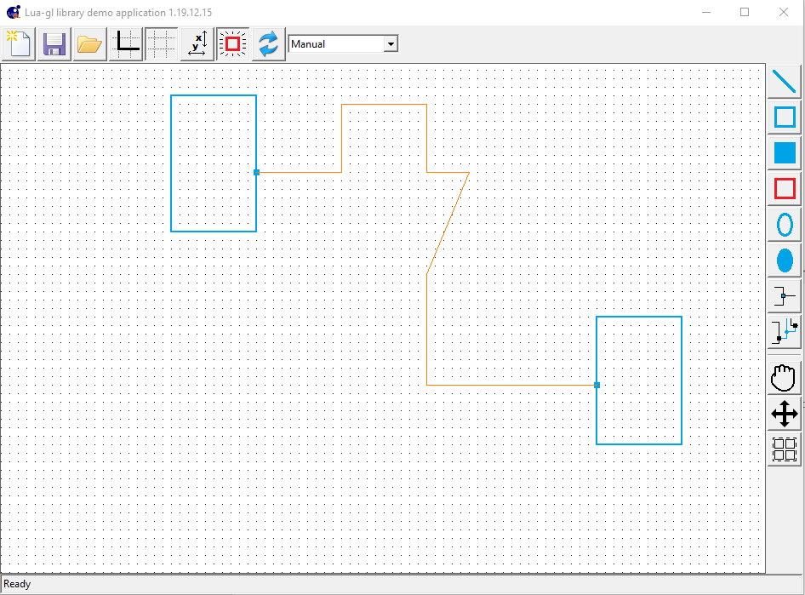
  - Click on drag button and pick the hump horizontal segment shown below:

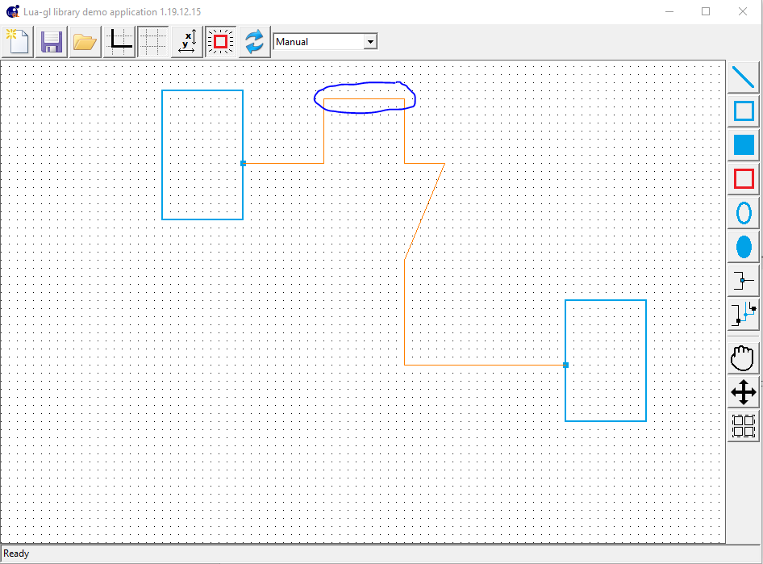
Dragging it down will keep the connector rerouted and end it to make the segment straight. After that select the vertical segment connected to the slanting segment. Move it to the right and when the slant becomes vertical end it. Now you will have a 3 segment connector as shown below:

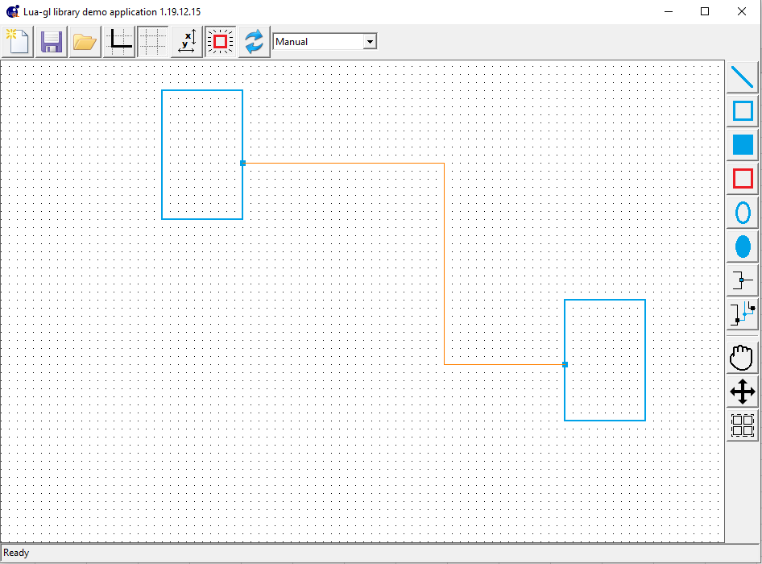
  - Now pick any of the 2 horizontal segment to drag. When you drag it the port should remain connected
  - Verify the connector structure and the routing matrix structure. Run utility.checkRM for quick check.
  - Now start again from testcase 7 and drag the hump as shown below:

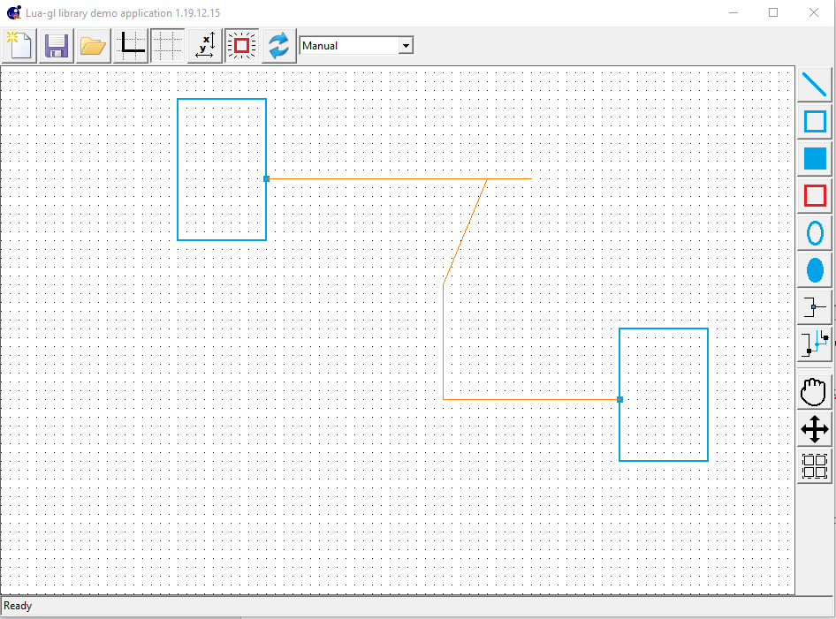
That is it gets in the same line as the horizontal segment below it but juts out along the line connected to the slanting segment. Now end the drag. The final connector should look like:

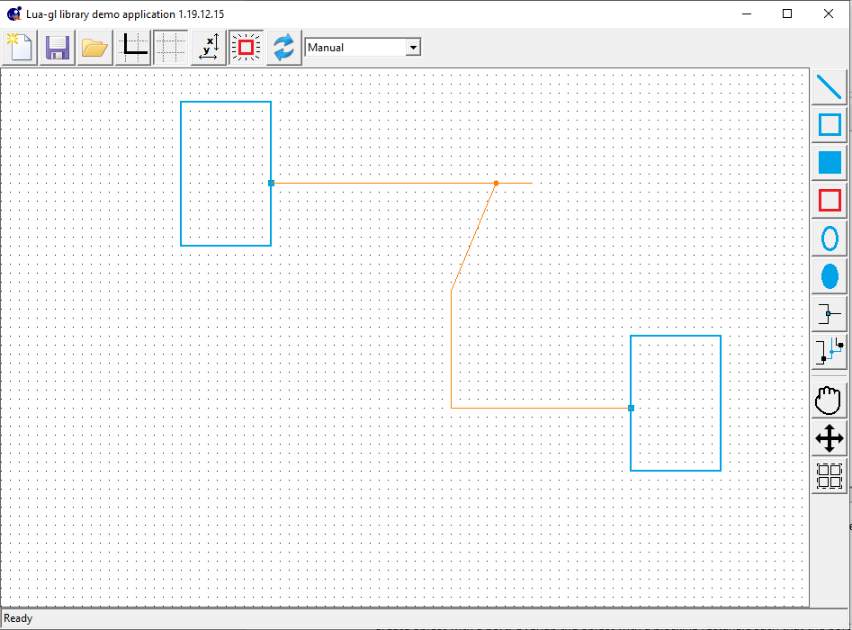
  - Now start again from testcase 7 and drag the hump to create the following:
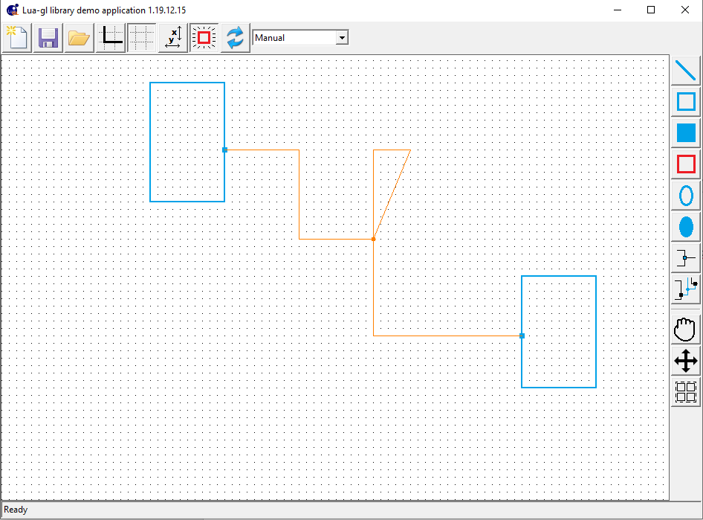
Now drag the top of the triangular loop. Both its end should reroute:
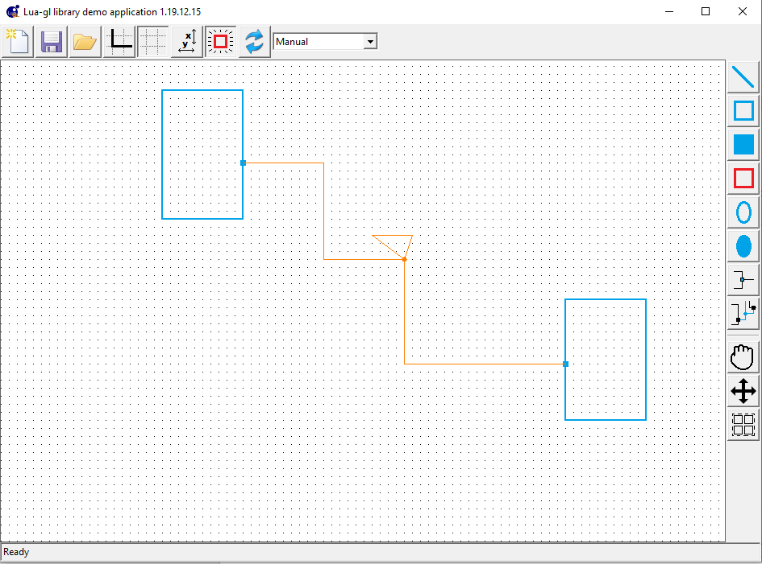
Merge it with the horizontal connector to get:
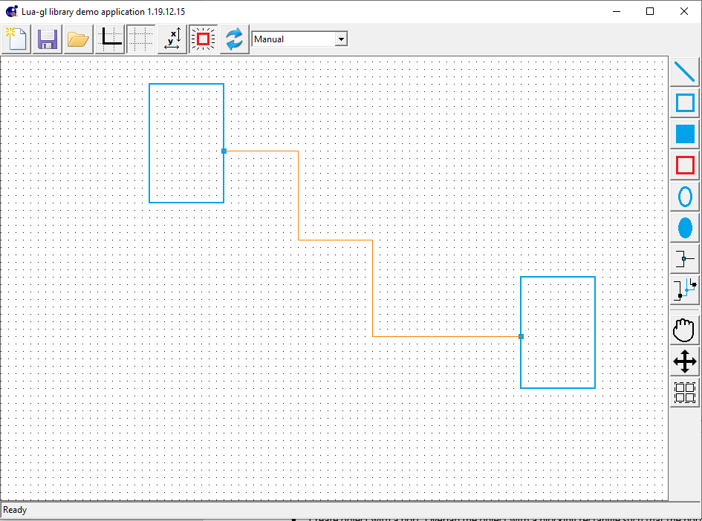

Other tests
- Create object with a port. Overlap the object with a blocking rectangle such that the port lies on the blocking rectangle boundary. See if you can draw a connector from that port.

